Restaurant Operations Analysis Using MySQL

# Project Objective

The primary objective of this project is to evaluate and improve restaurant operations using SQL-based data analysis. By exploring menu items, order details, and customer preferences, this study aims to provide actionable insights into performance optimization, customer behavior, and revenue trends.

# How This Analysis Helps the Client

This analysis enables The Taste of the World Café to:  
- Identify high and low-performing dishes across categories.  
- Understand order patterns and optimize menu offerings.  
- Pinpoint high-spending customers and behaviors.  
- Make strategic decisions for marketing, inventory, and staffing.

# Section 1: Menu Analysis

1. View all menu items

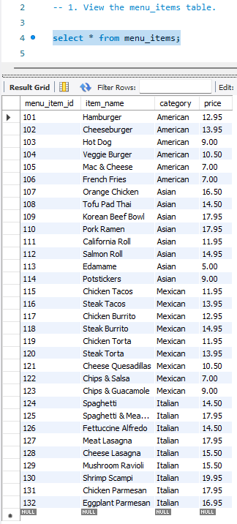

Insight: Allows visibility into all offerings available for analysis.

2. Find the number of items on the menu

Insight: The menu has 32 items, indicating a balanced variety.

3. Identify the least and most expensive items

Insight: Edamame is the cheapest at $5.00, Shrimp Scampi is the priciest at $19.95—highlighting a wide pricing strategy.

4. Count of Italian dishes

Insight: 9 Italian dishes, a key area of focus due to its volume.

5. Least and most expensive Italian dishes

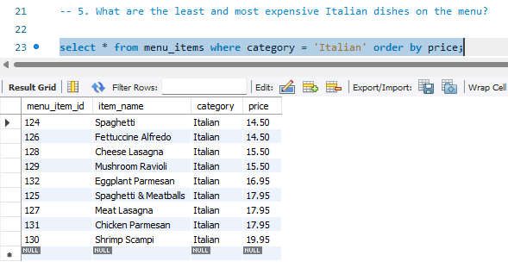

Insight: Shrimp Scampi is again the highest at $19.95, and Spaghetti/Fettuccine Alfredo are the lowest at $14.50.

6. Number of dishes in each category

Insight: Italian and Mexican lead with 9 dishes each, showing potential for targeted marketing.

7. Average price by category

Insight: Italian dishes have the highest average price ($16.75), suggesting premium positioning.

# Section 2: Order Data Analysis

1. View order details

Insight: Enables tracking of all order transactions for pattern recognition.

2. Date range of order data

Insight: Covers Jan 1, 2023 – Mar 31, 2023, offering insights for a full quarter.

3. Total number of orders

Insight: 5,370 total orders, suggesting strong customer volume.

4. Total items ordered

Insight: 12,234 items sold in the quarter, reflecting solid throughput.

5. Orders with most items

Insight: Orders with 14 items are the largest, indicating group or family orders.

6. Orders with >12 items

Insight: 20 large orders with 13+ items, ideal for upselling and bundling strategies.

# Section 3: Sales & Customer Insights

1. Least & most ordered items

Insight: Hamburger and Chicken Torta are most popular; Edamame is least. Customer preference leans toward American comfort food.

2. Top 5 spending orders

Insight: Top orders exceed $190, showing opportunities for premium promotions.

3. Insights from top spenders

Insight: These orders contain mostly Italian and Asian items, indicating popular premium categories.

4. Highest single-spend order

Insight: Order #440 had $192.15 spend with a mix of Asian, American, and Mexican items—highlighting the value of variety.

5. Top 5 orders by category breakdown.

Insight: Majority of top orders involved 3+ categories, underlining cross-category sales strength.

✅ **Overall Conclusions**

This analysis provides a comprehensive view of menu performance and customer behavior. Key takeaways include:  
- Italian dishes are priced higher and appear frequently in top orders, validating premium pricing.  
- American comfort items drive volume, while Asian dishes contribute to high-value orders.  
- Customer diversity in ordering behavior suggests the potential for bundled promotions across cuisines.  
- Order patterns show consistent high-volume activity, useful for optimizing kitchen operations and staffing.  
  
By using these insights, the café can refine its menu, target marketing more effectively, and develop pricing strategies that align with customer behavior—leading to better profitability and customer satisfaction.

# 

# Thank You

Project by: Dharmesh Parmar

Email: Dhparmar2119@gmail.com